Case 1: Already Solved
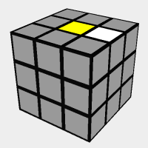

Case 2: White Edge in Right layer
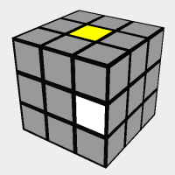
Solve By: Using the Algorithm “R”
Case 3: White Edge in Left Layer
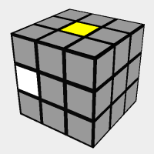
Solve By: Using the algorithm “Li”

Case 4: White Edge in Top Layer
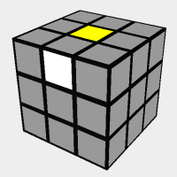
Solve By: Using either “F” or “Fi”. If “F” is used, solve with “R”. If “Fi” is used, solve with “Li”
Case 5: White Edge in Bottom Layer
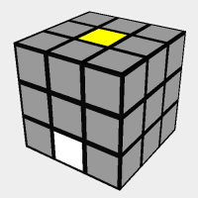
Solve By: Same as case 4, use “F” or “Fi”. If “F” is used, solve with “R”, if “Fi” is used, solve with “Li”
Case 6: White Edge on White Side
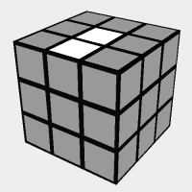
Solve By: Move F twice (“F2”) if underneath an open spot on the yellow side.
Note: the White side is now on top in this image.

