To solve the White cross, use the algorithm “U” or “Ui” until the second color to one of the white edge is aligned with its corresponding color.
Before:
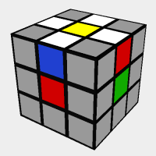
After:

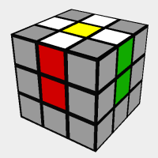
To solve from this point, just use the algorithm “F2” to move the white edge from the yellow side to the white side.
After the “F2” move:
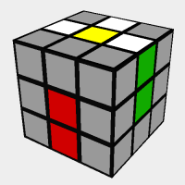
Repeat with the remaining edges until all of them are on the white side to form the white cross.

