Case 1: White corner on Top Right
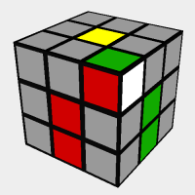
Solve by: Holding the red side in front and performing “R,U,Ri,Ui”.
Case 2: White corner on Top
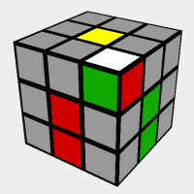
Solve By: Performing “R,U,Ri,Ui” 3 times.
Case 3: White corner in bottom right side
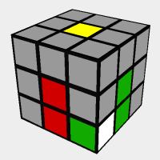
Solve By: Using “R,U,Ri,Ui” twice.
Note: The Red-Green-White corner only displays the green and white faces of the cuboids.

Case 4: White corner in bottom right on front side
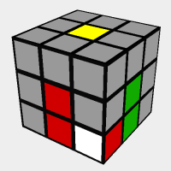
Solve By: Repeating “R,U,Ri,Ui” 4 times.

Note: When solving for a specific corner, you must place the corner between the two colors it needs to go between.

For example, you would have to move this corner between the red and blue sides by using U or Ui.
