Case 1: Yellow Dot
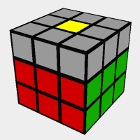
Solve by: Using “F,R,U,Ri,Ui,Fi” which will give you the “L”
Case 2: Yellow L
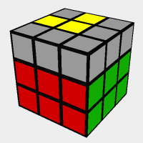
Solve by: “F,U,R,Ui,Ri,Fi”
Note: Make sure to place the Backwards “L” in the upper left.
Case 3: Yellow Line
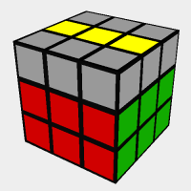
Solve By: Hold the cube so that the Yellow Line is horizontal, then use “F,R,U,Ri,Ui,Fi”.

