Case 1: Right Fish
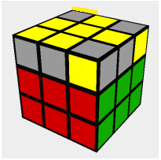
Solve by: Using the algorithm “R,U,Ri,U,R,U2,Ri”
Note: Hold the fish so that the head is in the bottom left. If there isn’t a yellow corner on the right while the fish’s head is in the bottom left like this:
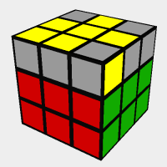
Then your cube is actually in case 2.
Case 2: Left Fish
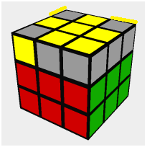
Solve by: Hold the cube with the fish head in the bottom right, then use the algorithm “Li,Ui,L,Ui,Li,U2,L”

Case 3: Cross with Headlights
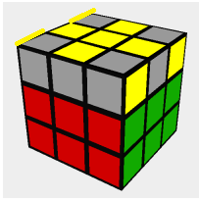
Solve by: Using “R,U,Ri,U,R,U2,Ri” while holding the headlights on the sides. This should get you to the right fish which is case 1.
Note: Headlights are when two corners are paired with/without the center edge. The yellow lines indicate where the other yellow corners are.
Case 4: Cross with One Set of Headlights
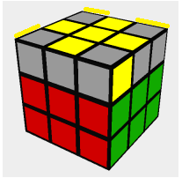
Solve By: Solve by: Using “R,U,Ri,U,R,U2,Ri” while holding the headlights in the back. This should get you to the right fish which is case 1. Make sure to hold the cube as it is shown above, but you don’t have to hold it with red and green as the front and right faces.
Case 5: Figure Eight
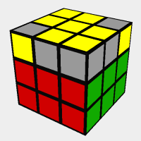
Solve by: Use “R,U,Ri,U,R,U2,Ri” which should get you to the left fish, which is case 2. Make sure to hold the cube so that there is one corner on the left.

Case 6: Tank with Headlights
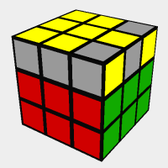
Solve by: Use “R,U,Ri,U,R,U2,Ri” while the headlights are on the right side. This should get you to case 5.
Case 7: Tank with Split Corners
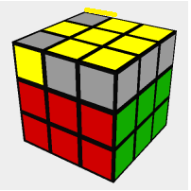
Solve by: Use “R,U,Ri,U,R,U2,Ri” which should get you to the left fish which is case 2.

