Case 1: No Headlights
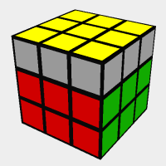
Solve by: Use the algorithm “Ri,F,Ri,B2,R,Fi,Ri,B2,R2,Ui” to produce a pair of headlights. Then look at case 2.
Case 2: One pair of Headlights
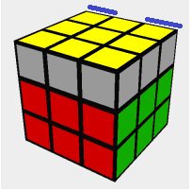
Solve by: Hold the headlights in the back, then perform the algorithm “Ri,F,Ri,B2,R,Fi,Ri,B2,R2,Ui”.
Note: The headlights can be any color(blue,red,green,orange), they do not have to be blue.

