Case 1: Clockwise Edge Cycle
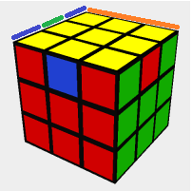
Solve by: Use the algorithm “F2,U,Ri,L,F2,R,Li,U,F2”.
Note: The colors do not have to be the same. The algorithm above just cycles the edges clockwise without affecting the back edge.
Case 2: Counterclockwise Edge Cycle
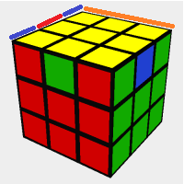
Solve by: Use the algorithm “F2,Ui,Ri,L,F2,R,Li,Ui,F2”.
Note: The colors do not have to be the same. The algorithm above just cycles the edges counterclockwise without affecting the back edge.
Case 3: No Solved Headlight Pair
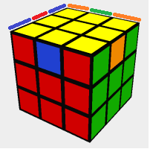
Solve by: Use the algorithm “F2,Ui,Ri,L,F2,R,Li,Ui,F2” to get one solved headlight pair. The cube should now be in the case 1 position.
Note: You only use the algorithm from case 2 if the edge to the left of the side you’re holding is the same.
For example:
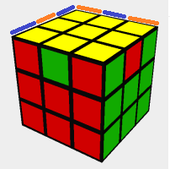
In this case, you would need to use the algorithm from case 1 which is “F2,U,Ri,L,F2,R,Li,U,F2”. After using it, you would then be in case 2.
Case 4: Headlights with Opposite Edge
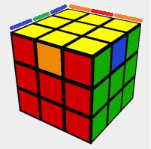
Solve by: Using the algorithm from case 1: “F2,U,Ri,L,F2,R,Li,U,F2”. After using it, you should be in case 1.

